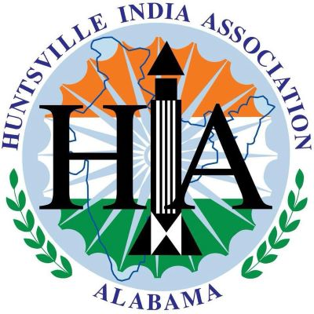
Huntsville India Association
SCHOLARSHIP PROGRAM 2024 APPLICATION FORM

Categories
This 2024 HIA Scholarship has been split up into two separate awards:
- HIA Scholarship for a local high school senior
- HIA Scholarship for a local student of Indian origin

Eligibility Criteria
HIA Scholarship for a Local High School Senior
- Must be a graduating senior in the class of 2024
- Must be nominated by an advisor belonging to a school system selected by the HIA Scholarship Selection Committee.
- Essay: In 400-500 words describe how Ancient India has impacted the Modern World. This category represents 30% of the overall score
- Must demonstrate the ‘service-before-self’ core value.
  - This category represents 35% of the overall score.
  - The student’s impact on the local community will be evaluated based on the length of service, position(s) held and specific contributions.
- Must demonstrate academic excellence.
  - This category represents 35% of the overall score.
- This scholarship will be sponsored by the Pushpa and Val Sapra Foundation.

HIA Scholarship for a Local Student of Indian Origin
- Must be a graduating senior in the class of 2024
- Home schooled students would also be eligible
- Must be of Indian origin
- Parents must be HIA members
- Resume
- Essay: In 400-500 words describe how Ancient India has impacted the Modern World. This category represents 30% of the overall score
- Must demonstrate the ‘service-before-self’ core value.
  - This category represents 35% of the overall score.
  - The student’s impact on the local community will be evaluated based on the length of service, position(s) held and specific contributions.
- Must demonstrate academic excellence.
- This category represents 35% of the overall score.
- Please email the document(s) to contacthuntsvilleindia+scholarship@gmail.com

Final Review
The final review will be conducted by the HIA Scholarship Selection Committee. Each selection committee member will get one vote for each category of award. At the end, the total votes will be tallied up and the winner will be selected.
Important Dates
- Last date of applications: March 31st, 2024
- Screening and review process will be finished by: April 15th, 2024, and applicants will be notified by email.
- Scholarship awardees will be felicitated on stage during the HIA 2024 Diwali celebration (date to be announced)

Questions? e-mail: contacthuntsvilleindia+scholarship@gmail.com Website: https://www.hiaweb.org.

Eligibility: Applicants must meet these criteria to be eligible. Please initial.
1. ____ I confirm that I am admitted to a US accredited university as a freshman in a 4-year undergraduate program.
2. ____ I confirm that I am a ward of an HIA member.

Personal Details:
1. Name:
a. Applicant’s First name-- Middle name-- Last name:
________________________________________________________________
b. HIA Member’s (Guardian of Applicant’s) First name-- Middle name-- Last name:
________________________________________________________________
2. Have you ever received HIA scholarship before?
___Yes (Year: ________) or ___ No.
3. Home address:
Address: _________________________________________________________
Address: _________________________________________________________
City: ___________________State: _____ Country: _______ZIP: _____________
4. Primary telephone: (________) ______________________
5. Secondary telephone: (________) _____________________ Extension: ______
6. E-mail: _____________________________________________
7. Date of Birth (MM/DD/YYYY): _______/ _______/ ___________
8. Which school did you/do you currently attend?
Name: ___________________________________________________
City: _______________________ State: _____ ZIP: __________
Phone number: (________) ______________________
What is your current GPA? __________
9. SAT/ACT Scores: SAT_______________ ACT______________
10. List any other institutions you have attended:
a. Name: _______________________________________________________
City: _______________________ State: _____ Years: ______________
b. Name: _______________________________________________________
City: _______________________ State: _____ Years: ______________
11. Extra-curricular Activities (Sports/Fine Arts/Robotics/ Others (Please Mention):
______________________________________________________________________
______________________________________________________________________
______________________________________________________________________
______________________________________________________________________
______________________________________________________________________
12. Community Involvement:
______________________________________________________________________
______________________________________________________________________
______________________________________________________________________
______________________________________________________________________
13. Certification Statement:
By signing my name below, I confirm that all of the information provided above and
in the accompanying documents is true and correct to the best of my knowledge.

Signature of the Applicant: ___________________________

Signature of the Guardian: ___________________________Date: _______________

School system will alternate among Madison City, Huntsville City and Madison County every year in order. Since Huntsville City was selected in 2023, this year it will be Madison County’s turn.
The HIA Scholarship Committee will consist of one representative from the HIA Board and two from the HIA Committee. To ensure fairness, in situations with a conflict of interest, the specific Scholarship Committee member(s) will be asked to step down.

